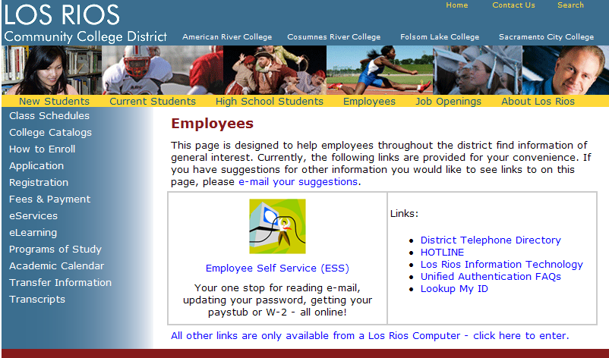

*Please Note: Popup blockers must be turned off in order to view the pay stubs and W-2 forms.  The following website has additional guidance on turning off popup blockers:* [*http://www.losrios.edu/lrc/emp_faq_detail.html#popup*](http://www.losrios.edu/lrc/emp_faq_detail.html#popup)*. You may click on the previous link, or copy it and paste it into your browser.*

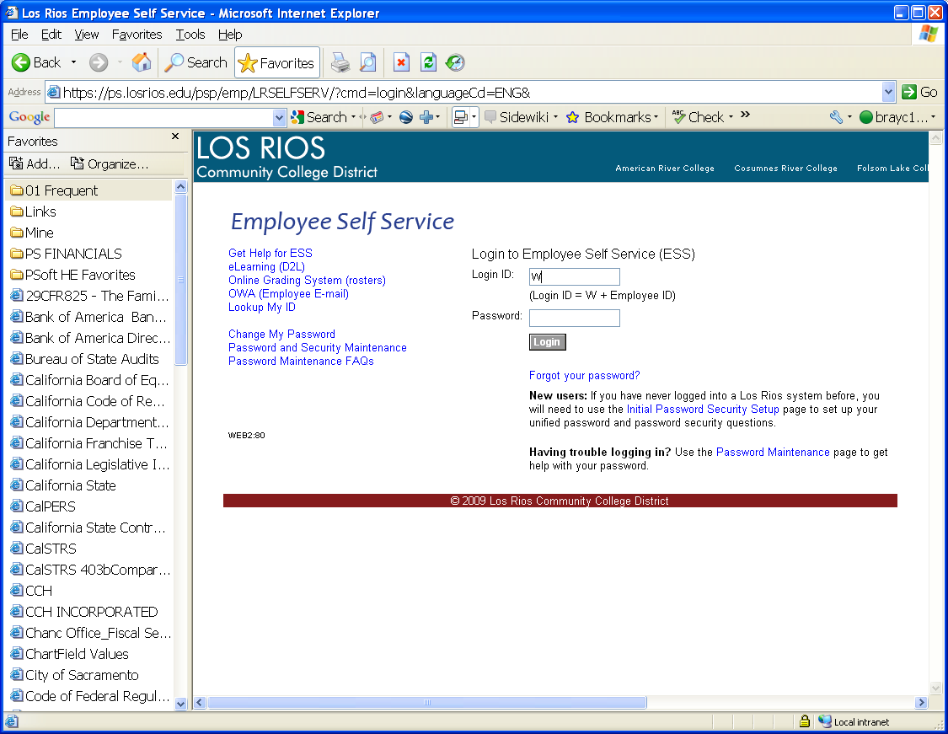

***Note: Employees will use their unified Login ID and Password to login to the Employee Self Service portal.***

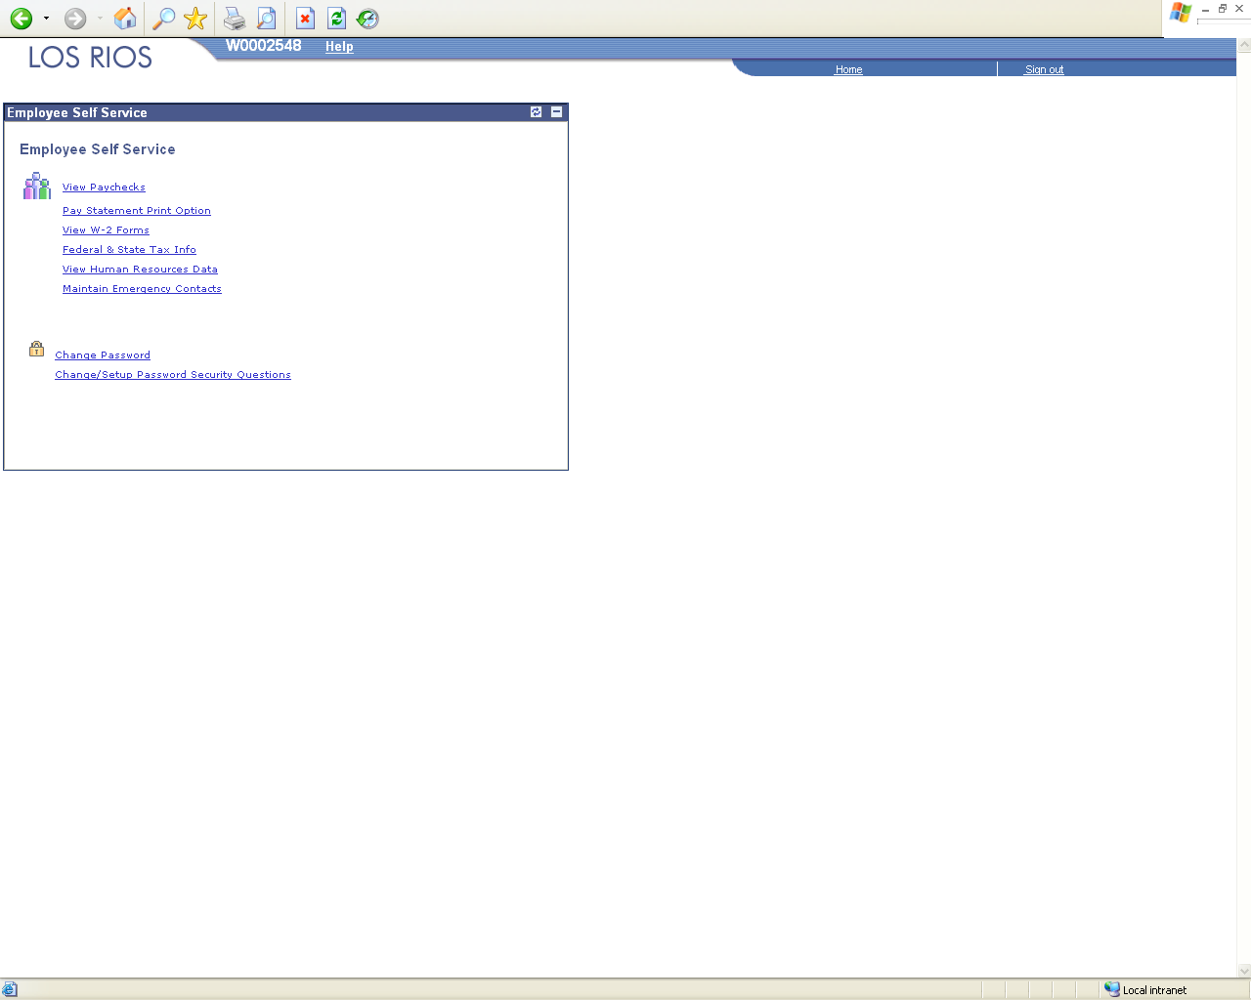

***Note: Links to the D2L Faculty Request Interface functionality will appear on the right side of the page for employees with access to these links.***

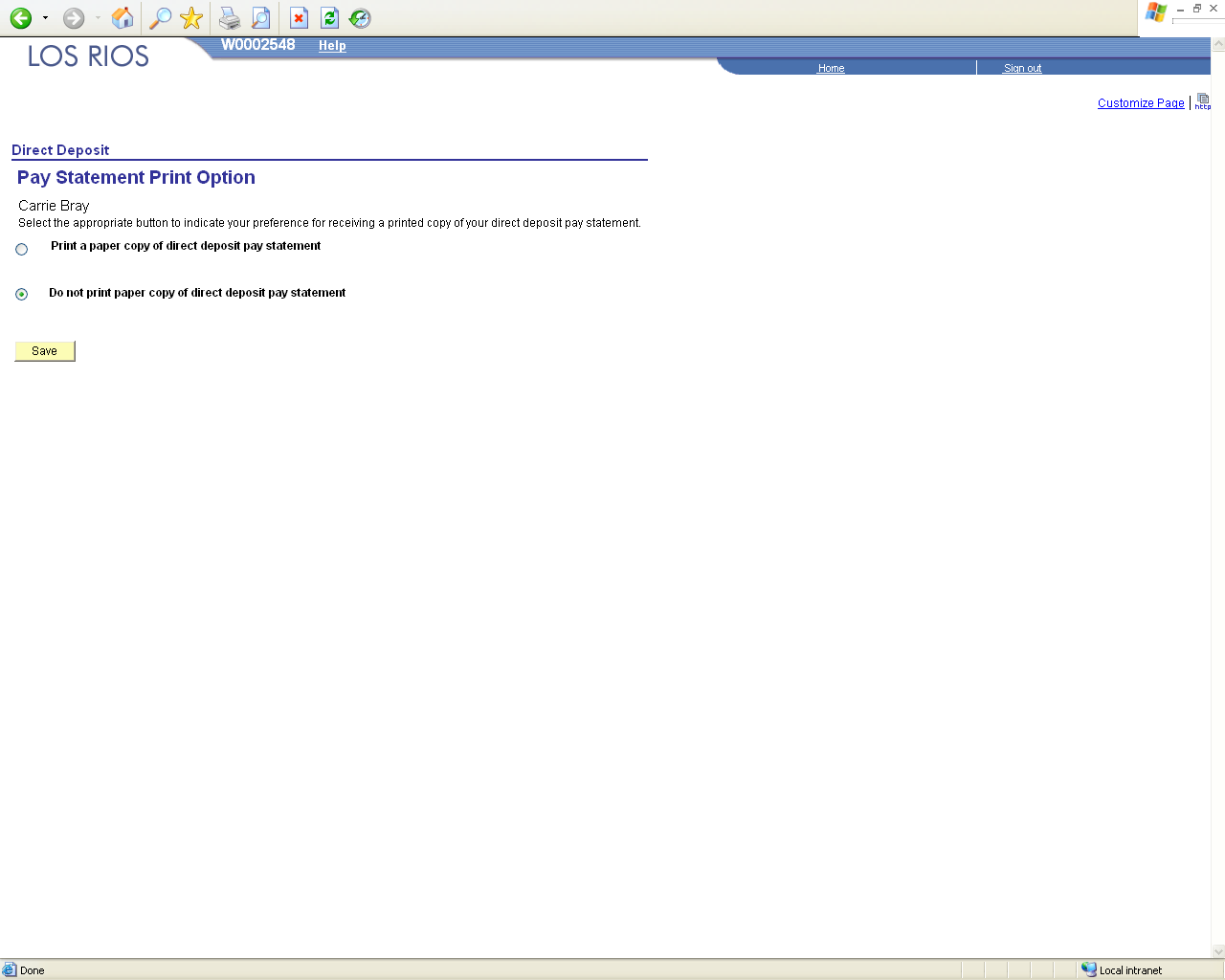

**To opt out of receiving a hard copy of your pay stub, select “Pay Statement Print Options” shown on the previous page of this guide. You will be directed to the page above.**

* Easily access important Payroll and HR information through the following links:
  + **View Paychecks** – view copies of your paychecks/advices (09/30/08 forward)
  + **View W-2 Forms** – view copies of your W-2 forms (2007 forward)
  + **Federal/State Tax Info** – download W-4 and DE-4 tax withholding forms to modify your tax withholdings. (Note: Submit completed tax withholding forms to Payroll via interoffice mail.)

Payroll Data Questions? Contact the Payroll Department at (916) 568-3025

* + **View Human Resources Data** – view name, address, and phone number on file with Human Resources; maintain emergency contacts; download Name/Address Change Form (Note: Submit completed Name/Address Change Forms to HR via interoffice mail.)
  + **Maintain Emergency Contacts** - add or change your emergency contact information.

HR Data Questions? Contact your Human Resources Specialist:

* + - **F/T Faculty and Management staff** call (916) 568-3109
    - **Classified, Student Help or Federal Work Study staff** call (916) 568-3107
    - **Employee Service Agreement (ESA) staff** call (916) 568-3179
    - **Adjunct Faculty staff** (Last names starting with the letter) call:
      * A - G (916) 568-3119
      * H - Pa (916) 568-3148
      * Pb - Z (916) 568-3172

*Please Note: Popup blockers must be turned off in order to view the pay stubs and W-2 forms.  The following website has additional guidance on turning off popup blockers:* [*http://www.losrios.edu/lrc/emp_faq_detail.html#popup*](http://www.losrios.edu/lrc/emp_faq_detail.html#popup)